12-5-13

**Hi-Jacked !**

A many of you know, a group of us filed an appeal on the lawsuit against the town for violating the General Plan.  We are asking the developer of the Albright site to stick with the General Plan requirements as written in 2010 to last for the following 10 years.  Our own people wrote it and our government approved it. Now the current government wants to negate the value of all that planning done 3 years ago.

Yes, the council gave the ok to violate the General Plan.  Politicians make mistakes too.  (Think of a onetime top politician and the Weapons of Mass Destruction)  Some politicians get called on the carpet for lying or making those mistakes (Think of Weapons of Mass Destruction).

We called our politicians onto the carpet for first ok’ing 85’ heights which resulted in the height being reduced to 65’. We also forced the largest project ever in Los Gatos to do an EIR. The Sisters of the Holy Name are selling off 17 lots and they did an EIR without being asked ! They didn’t need to be sued. They did it right the first time.

Regardless, the 65’ still exceeds the stipulation in the General Plan by 30 feet more than our “rigid standards” allow.  **Higher buildings equal more traffic and higher density**.

More traffic = longer commutes = longer trips around town for you = no pain for the developers; just money.

The tax impact difference between what they want and what the General Plan would allow are  **more than compensated** for when you add in the other projects built or being built going back to when the first house went up on Blue Bird Lane to whenever the Albright and North 40 are finished.

The developers were very quiet after I published my estimate of tax revenues both at the council meeting and to the Los Gatos Weekly Times. Did they not want that information out there for the public to see? I used their cost projection numbers and their web site information so that we were essentially comparing apples to apples. These numbers were then used to figure the tax revenues that would be forthcoming to the schools and the town, plus most of the fees, from the 10 largest projects.

 The North 40 is a much bigger tax revenue producer than Albright (aka Netflix).  **Much Bigger.** Going back to the start of Blue Bird Lane to the completion of either Albright or North 40 (whichever comes last). The top 10 projects alone **will bring in over $10,000,000 as a first year hit, and over $5,000,000 of NEW recurring revenues every year.** By my calculations, those go just to the schools and the town will receive their own large lumps of money. And those numbers are only for the 10 projects. There are many other projects that will contribute money to the town and the schools. If I can find the time, I think I might do those and make you feel really good. Maybe we could even pave the Grove.



The developer, with help from a couple of friends and a contractor that makes money off them is feeding you partial truths about tax revenues.

1. The town is already receiving the tax revenue from the land sale back in 2011. It can increase only 2% per year due to Prop 13.
2. If you add the tax revenues from the 10 largest projects since Blue Bird, and only use the tax revenue generated by the environmentally friendly sized buildings, the “loss” of revenue by not building the higher buildings is minisc

My gut feel is that they, along with the driving forces of of LezLi Logan and Cynthia James, are leveraging the parents’ lack of clear information by making them think that the schools will be broke without the Albright tax revenues to support them. One, if not both, are employed by the developer. They’re waving their arms and screaming about jobs, losing Netflix and money to the schools, so let’s look at those claims.

#1: If built as planned, Albright will be more than twice the size of the buildings that were there before, and, with the new hi-density employee configurations, could be 300-400% more employees and cars than before. It’s a big deal. But then, add in the North 40 project and the growth and traffic almost become exponential. Remember that the businesses that were there before were 90% occupied. Do you think new buildings will be a detraction to getting new tenants, regardless of who wants the space?

#2 Another argument they use is to keep employment in Los Gatos. However, Los Gatos already has an extremely low unemployment rate of 4.4% ; the Santa Clara County unemployment rate is 8.9% ; and the state of California is 8.7% -  based on the latest Bureau of Labor Statistics numbers (August thru October of 2013).

How many people of the 4.4% unemployed do you think will be qualified to get a job at Netflix?  Many of the current employees come here on buses from as far as San Francisco, which is the preferred spot to live for the younger generation.  Work here, create traffic, eat at Netflix; go home to SF.

#3 Another argument they use is that we’ll lose Netflix. However, I can find no where that Netflix ever said that. They did say they want to stay in Los Gatos. Nothing more that I can find and they signed a 10 year lease for 2 buildings which could still be built under an appropriately scaled-back project. We’re for development – just play by the towns own rules ! Let’s wait for Netflix to say they won’t stay, not what a developer is telling you.

# 4 By the way, did you know the developers initiative will cost Los Gatos up to $100,000? And for what? They already have the 485,000 sq. ft. Is the reason so that can take over the land use planning for the town of Los Gatos? Is it because they know they’re in a weak position with the law suit? Do they know we’re right? Is it to intimidate us and the council?? Our budget has been in the red. Can the library and the police take another $100,000 deduction without cutbacks? What’s with this action? CYA? Intimidation?

#5 Politicians, like most of us, don’t like to admit they violated their own rules, but they, and the Town Manager, Greg Larson, have never responded to us as to why they think they can violate the General Plan………………so how and why can they usurp their own rules ?  The only way we found to get them to obey their own rules was to sue them and the developers. We didn’t want to do that. And, we like the council people; they work hard – but when they’re wrong, they need to admit it and get on with supporting the citizens - not the developers.

#6 And about those developers. There are three huge, very wealthy firms starting with [Carlyle Group](http://en.wikipedia.org/wiki/Carlyle_Group) in Washington DC, with over **$170** **Billion** under management, along with Sandhill Properties of Redwood City (Peter Pau- see [Sunnyvale Mall](http://www.mercurynews.com/my-town/ci_24470548/more-appeals-mean-more-delays-sunnyvale-town-center) ) and Adamas Ventures of Palo Alto.  I recommend you stay in touch with the Sunnyvale suit. Is this what’s starting to happen to Los Gatos with the initiative?! Is more coming?

They come, they develop, they make money and they leave us with the consequences.

Wham! Bam! Thank you Ma’am!

They will be receiving monthly rent checks while you sit in traffic. Is unfettered growth good? Is this progress?

#7 We need your help to keep Los Gatos development within the bounds set by the General Plan.  This is a great place to live and you have some huge, wealthy developers forcing their way into our town processes. None of them are based here. None of them will suffer the consequences.

And keep in mind the Developers are currently putting an initiative on the ballot to usurp our Planning Commission and our Town Council of their powers to control some land use!  If we lose that, it is possible that all developers can use this precedent to run our town planning, forever.  They’ll tell you this initiative is only for this piece of land. Do you think the other developers have their ears plugged and eyes wide shut?

We’re residents asking you to look at the facts and don’t listen to the hype. We too want Netflix, but we want them to follow the same rules all the rest of us have to follow. The tail should not wag the dog.

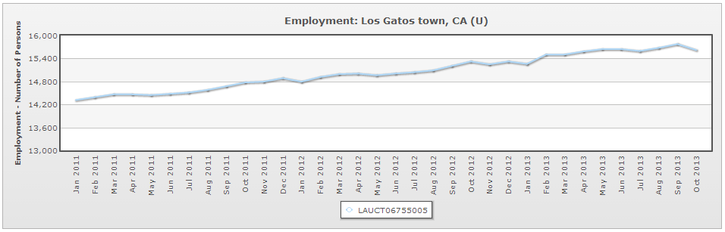

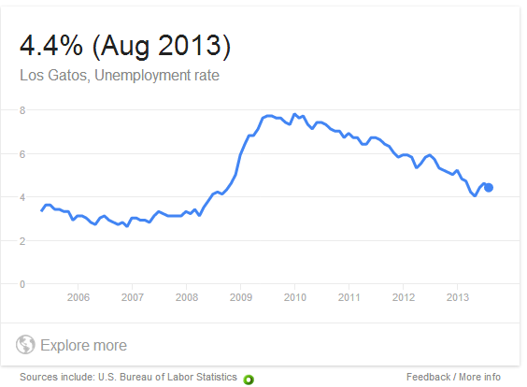

Jak Van Nada

Los Gatos Long Time Resident